System & Tool & Ecosystem

Operating Systems; Hardware Fundamentals; Compute Environments; Remote Access & Networking; Developer Environments; Tools (Applications)

Operating Systems
- Windows
- macOS
- Linux
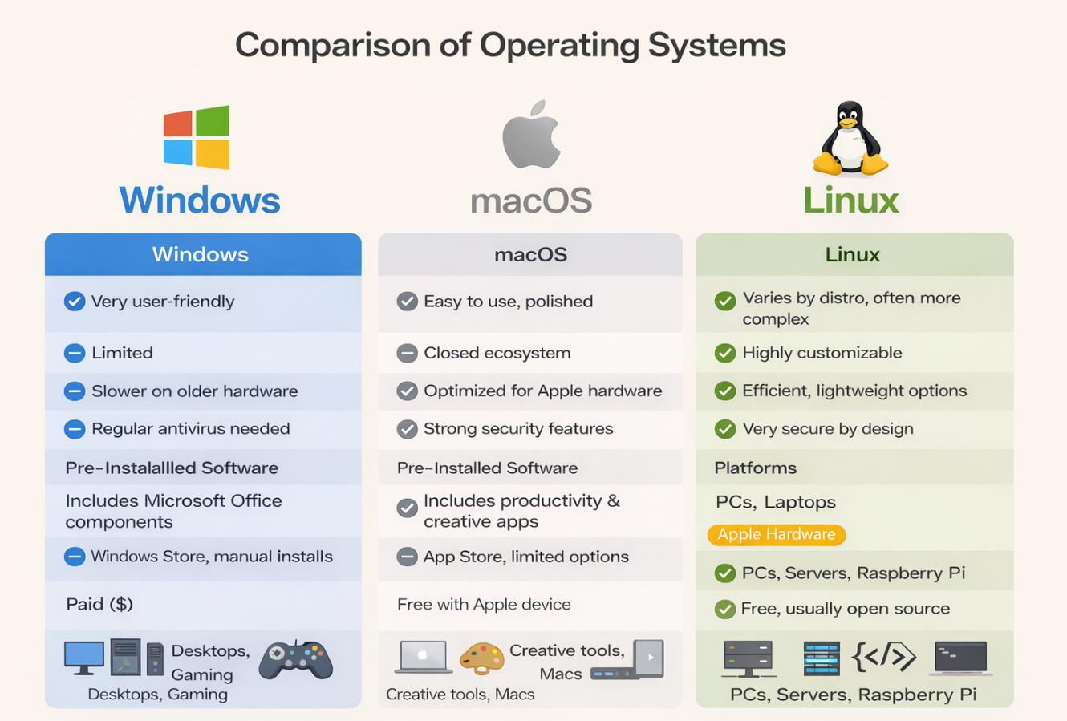

Hardware Fundamentals
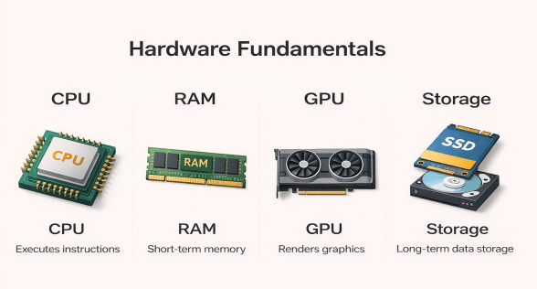
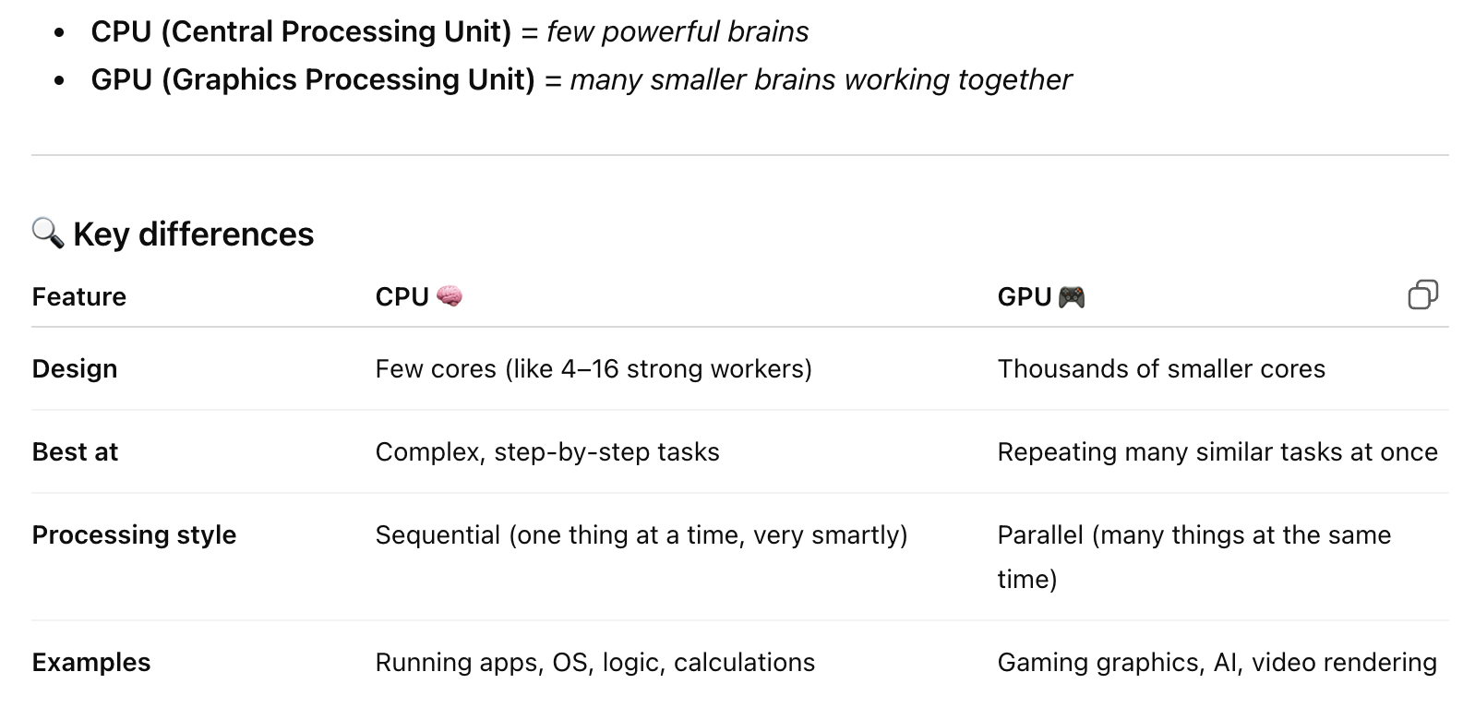

Compute Environments

- Mac Book Air M3: 24GB: high-end lightweight laptop
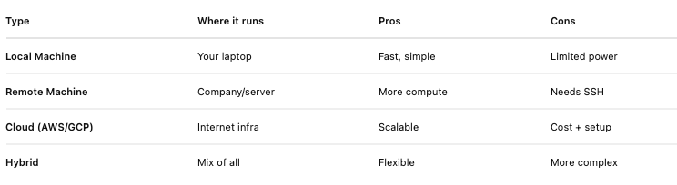

Remote Access & Networking
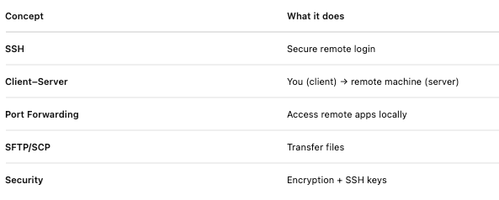
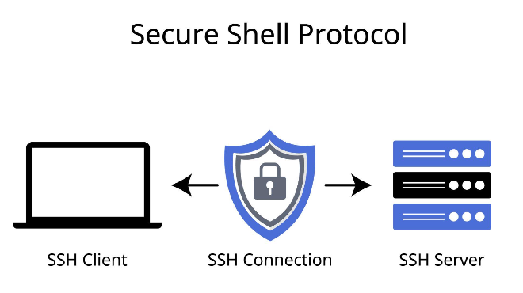

Developer Environments
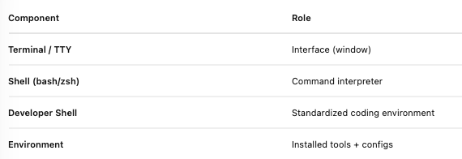

5.1 Developer Shell
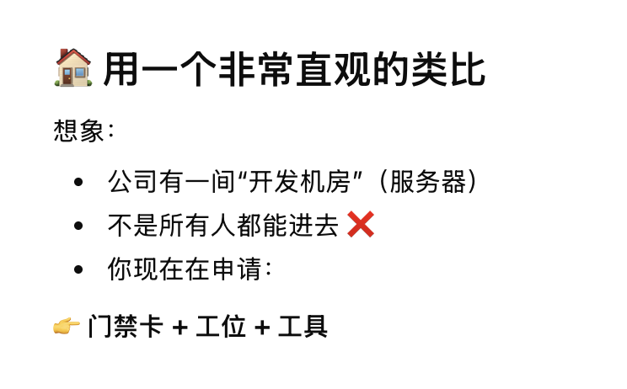
Developer Shell = a secure remote terminal that lets you log into company servers and run code in a standardized development environment.

Tools (Applications)
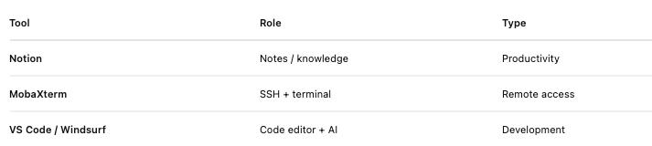
Notion
Electron-based app(basically a browser); Uses:.CPU; RAM; .Network

MobaXterm
- A Windows tool that lets you work with remote Linux/Unix systems as if they were local.
  - SSH into remote servers
    - Log into: Linux VMs; Research Servers; GCP/AWS machines
    - Run:
      - Python
        - # hello.py
        - Print ("Hello, world!")
      - R
        - # hello.R
        - print("Hello, world!")
        - x <- c(1, 2, 3, 4, 5)
        - mean(x)
      - C++binaries(meaning)
        - // hello.cpp
        - #include <iostream>
        - using namespace std;
        - int main() {
        - cout << "Hello, world!" << endl;
        - return 0;
        - }
      - Batch Scripts(meaning)
        - # run.sh
        - echo "Running script..."
        - python hello.py
See how C++/Java is embedded in BLK system

7. Execution & Workflows

Developer Shell

Developer Shell = a secure remote terminal that lets you log into company servers and run code in a standardized development environment.

RAM (short-term,memory), CPU, GPU


